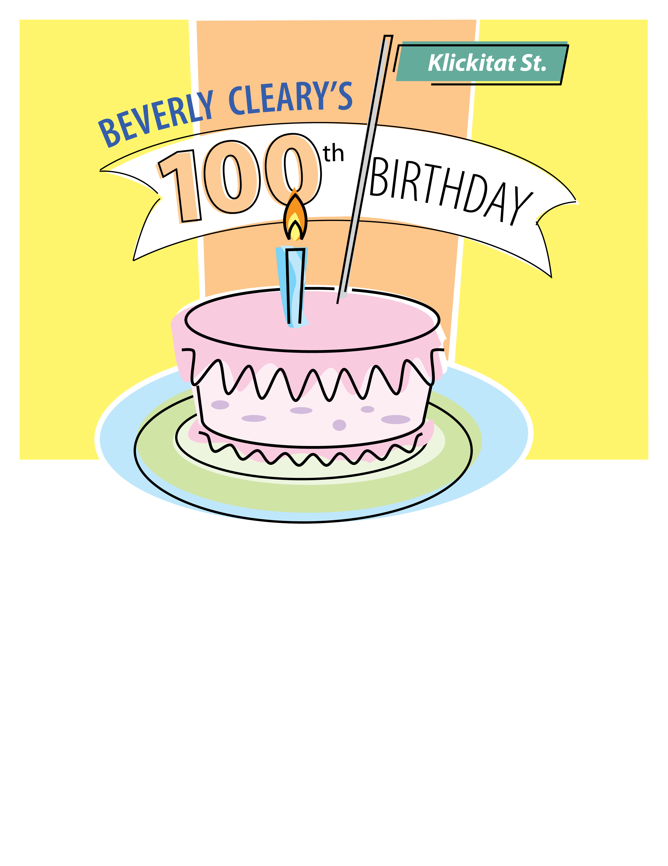

Beverly Cleary Event title

Description

Date

Time

Location